Informational Page

Definition
# Source: AI Source: Provided by: [Data Path: Persons Table -> ID Column: 1, Name_En Column: Motasem Essam] -> From: [Chatgpt (GPT‑5 Mini)] on [2/12/2026]
An Informational Page is a web page that provides useful information to visitors about a specific topic, subject, product, service, or idea without requiring any action from the user.

Simple Definition
# Source: AI Source: Provided by: [Data Path: Persons Table -> ID Column: 1, Name_En Column: Motasem Essam] -> From: [Chatgpt (GPT‑5 Mini)] on [2/12/2026]
Informational Page = a page that explains and shares information to help users understand something clearly.

What an Informational Page Usually Includes
# Source: AI Source: Provided by: [Data Path: Persons Table -> ID Column: 1, Name_En Column: Motasem Essam] -> From: [Chatgpt (GPT‑5 Mini)] on [2/12/2026]
• Clear Content – detailed explanations about a topic
• Headings & Subheadings – to organize information
• Text, Images, or Videos – to make content easy to understand
• Facts or Details – accurate and helpful information
• Examples (optional) – to clarify ideas

Purpose of an Informational Page
# Source: AI Source: Provided by: [Data Path: Persons Table -> ID Column: 1, Name_En Column: Motasem Essam] -> From: [Chatgpt (GPT‑5 Mini)] on [2/12/2026]
• Help users learn and understand a topic
• Provide knowledge without needing interaction
• Support education or awareness
• Help users make informed decisions

Examples
# Source: AI Source: Provided by: [Data Path: Persons Table -> ID Column: 1, Name_En Column: Motasem Essam] -> From: [Chatgpt (GPT‑5 Mini)] on [2/12/2026]
• Blog articles
• Product descriptions
• Wikipedia-style pages
• Guides or tutorials
• News articles

Difference Between Informational Page and FAQ Page
# Source: AI Source: Provided by: [Data Path: Persons Table -> ID Column: 1, Name_En Column: Motasem Essam] -> From: [Chatgpt (GPT‑5 Mini)] on [2/12/2026]
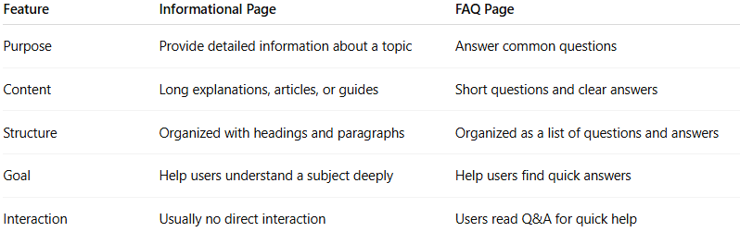
Feature | Informational Page | FAQ Page
Purpose | Provide detailed information about a topic | Answer common questions
Content | Long explanations, articles, or guides | Short questions and clear answers
Structure | Organized with headings and paragraphs | Organized as a list of questions and answers
Goal | Help users understand a subject deeply | Help users find quick answers
Interaction | Usually no direct interaction | Users read Q&A for quick help

